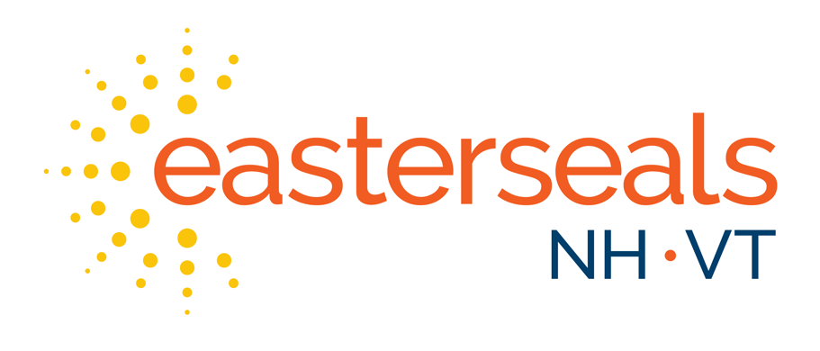


Campaign 2026
TOOLKIT

STORIES
Early Childhood Centers of Excellence Help Marissa’s Daughters Thrive
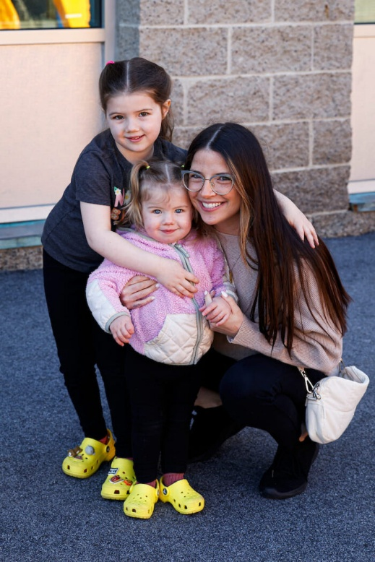
Easterseals NH’s Early Childhood Services elevate children of all abilities, providing child care, therapeutic, and developmental services to 2,357 children in fiscal year 2024.
We provide in-home early developmental intervention around New Hampshire through Family-Centered Early Support and Services. Our Children’s Therapeutic Services offer extensive outpatient care at our Manchester and Salem, NH locations. Our Early Childhood Centers of Excellence (ECCE) in Manchester, NH, deliver integrated services to meet the developmental and therapeutic needs of children within our nationally accredited child care program.
Kate shared the positive impacts our ECCE has had on her children. Her daughter Zoey struggled with social interactions but improved significantly in our program. “When we walk into the playground every morning, her friends come to the gate so excited that Zoey is there,” Kate explained.
“When Zoey first came to Easterseals New Hampshire, she was very quiet, didn’t really interact with other children,” added Mariah Reed, Assistant Director of Easterseals NH ECCE. “Through many connections, we were able to get her the services that she needs.”
Kate’s son Theo benefits from our integrated services model, receiving speech therapy through ECCE. “His speech has grown the last two weeks since he started,” Kate noted. “The teachers incorporate everything he’s learning.”
“We’re so fortunate to have so many services right here,” added Kristen McGuigan, Senior Vice President of Easterseals NH Early Childhood Services. “There’s this really beautiful way of collaborating and really focusing on continuum of care.”

STORIES
From Estrangement to Home: How One Coast Guard Veteran Rebuilt Her Life with Veterans Count
When Denise*, a highly decorated United States Coast Guard Veteran, entered treatment in early 2024, she believed she had lost everything that mattered most, her health, her home, and her relationship with her children.
Living with the lasting effects of severe service-related trauma and a 100% service-connected disability, Denise had spent years trying to survive the invisible wounds of military service. Like many Veterans, she turned to substances to numb the pain. The cost was devastating, financial collapse, housing instability, and years of estrangement from her children.
“I didn’t think my life could look any different than it did then,” Denise later shared. “I couldn’t imagine a future.”
In March 2024, while enrolled in a partial hospitalization program following a VA inpatient stay, Denise was referred to Veterans Count, a program of Easterseals New Hampshire. At the time, she was facing recovery with little support and no clear path forward.
Over the next year, Denise worked side-by-side with her Veterans Count Care Coordinator to rebuild every part of her life, one step at a time.
With steady guidance and advocacy from her Veterans Count Care Coordinator, she secured permanent housing, re-entered the workforce, and began full-time employment at a human services organization. There, her leadership and resilience quickly stood out, leading to multiple promotions in less than a year.
Just as critical was her commitment to healing. Denise established consistent medical and mental health care, built healthy routines, and remained engaged in long-term recovery, laying a foundation she had never believed possible.
But the most meaningful transformation came at home. After years of separation, Denise began rebuilding relationships with her children. On her 50th birthday, she celebrated a moment she once thought she would never see, all of her children gathered by her side.
“I could never have imagined that when we first met,” she told her Veterans Count Care Coordinator.
Eighteen months after first connecting with Veterans Count, Denise remains in recovery, permanently housed, steadily employed, and actively working with a financial counselor to build long-term stability. Her story is one of resilience and what is possible when Veterans receive the right support at the right time.

* Denise’s real name is withheld to protect her privacy.

STORIES
Finding Purpose and Joy: Maria’s Journey with Easterseals NH Adult Day
Easterseals NH’s Senior Services elevates people of all abilities by supporting older adults’ health, safety, and independence at home and in the community. Our In-Home Care and Health Services provide an affordable alternative to nursing home care tailored to each client’s needs. Our Adult Day Programs in Manchester and Rochester, NH, offer stimulating community settings for social engagement, exercise, activities, and integrated care.
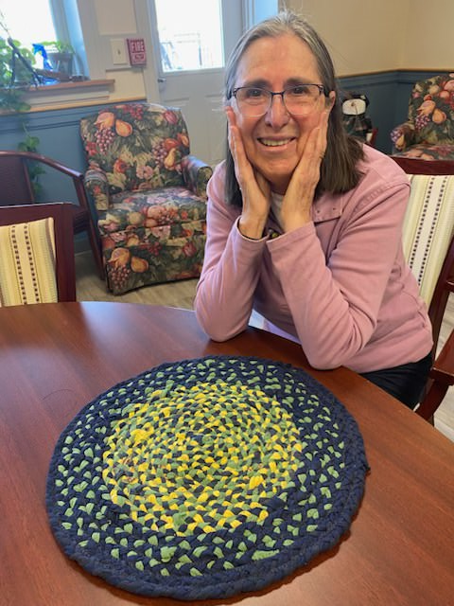
Before joining the Easterseals NH Adult Day program, Maria spent most of her days at home. Her daughter, concerned about her becoming isolated or depressed, encouraged her to give the program a try.
“I thought I wasn’t old enough for a program like this,” Maria said with a chuckle. Maria wasn’t expecting to discover a creative side she never knew she had. “I had never really done much art before I came to the program, but now I love it.” She proudly shared a photo of a colorful placemat she made using recycled T shirts. “I love painting, and now I even paint a bit at home. It’s special because I bring some of my artwork home, and my daughter gets to see it and know I’m involved.”
Maria’s artwork has even been featured in the Adult Day Craft Fair. In addition to arts and crafts, Maria enjoys the exercise opportunities, especially the enhanced fitness classes—where 62% of participants show improvement or stability in their fall risk.
Originally from Chile, Maria loves sharing pieces of her culture with others. “Maria shares her culture, and we learn from her as much as she learns from us,” said Sue Reynolds, Director of Adult Day Services in Manchester.
“I find this program so rewarding, and it gives me a sense of purpose,” Maria said. Maria’s days are now filled with conversation, creativity, and connection. She loves engaging with other participants, and she has even exchanged phone numbers with a few, staying in touch with her new friends outside the program.

Sample Emails
Easterseals NH Sample External Email
Subject: Join Me In Elevating All Abilities In New Hampshire
Dear [Name],
I am writing to ask for your or [organization name]’s continued support of Easterseals NH by joining our annual Very Important Partner (VIP) Campaign. This fundraising campaign helps us provide best-in-class programs to more than 14,000 children, adults, seniors, and Veterans in New Hampshire each year.
Your dedication allows Easterseals NH to provide plans of care comprised of thoughtfully integrated services that help those with varied abilities live, learn, work, and play throughout their lifetimes.
Since 1936, Easterseals NH has been here for people of all ages and abilities. We are known for our clinical expertise and the breadth and depth of our services and programs, which provide individuals and families with the support they need to live their best lives.
Easterseals NH’s services in New Hampshire include child care and early intervention for children, employment and education opportunities for youth and adults, aging with independence and dignity for seniors, mental health support and care coordination for service members, Veterans, and their families, and so much more.
When I donate to a nonprofit, I want to see my contributions making a difference in my community. Giving to Easterseals NH ensures that your funds will support New Hampshire residents and go directly to your neighbors in need.
This year, Easterseals NH aims to raise $375,000 through the VIP Campaign to guarantee critical services and programs for those who rely on them. I invite you to join me in furthering Easterseals NH’s mission. Every gift, no matter the amount, helps ensure people of all abilities and stages of life have access to transformative supports and services.
Join me and become a VIP today by donating at [insert personal fundraising page URL].
If you have any questions, please contact me at [phone#] or [email address].
Thank you for your support.
Sincerely,
[Name]

P.S. To witness the difference Easterseals NH is making in communities across New Hampshire, follow us on social media at https://www.facebook.com/EastersealsNH

Sample Emails
Easterseals VT Sample External Email
Subject: Join Me To Empower Children and Families in Vermont
Dear [Name],
I am writing to ask for your or [organization name]’s continued support of Easterseals VT by joining our annual Very Important Partner (VIP) Campaign. This fundraising campaign helps us provide best-in-class programs to approximately 2,000 individuals each year, including at-risk youth, foster youth, and families formed by adoption or guardianship throughout Vermont.
Your dedication allows Easterseals VT to provide critical care and resources for Vermonters facing hardships in your community.
Easterseals VT provides services throughout the Green Mountain State, often partnering with the Department for Children and Families (DCF) to find family-centered solutions to ensure the safety and well-being of children and their families.
Easterseals VT supports at-risk youth, foster youth, and families formed by adoption or guardianship, finding practical, realistic solutions for children suffering from abuse, neglect, bullying, and insufficient help and understanding.
When I donate to a nonprofit, I want to see my contributions making a difference in my community. Giving to Easterseals VT ensures that your funds will support Vermont residents and go directly to your neighbors in need.
This year, Easterseals VT aims to raise $14,500 through the VIP Campaign to guarantee critical services and programs for those who rely on them. I invite you to join me in furthering Easterseals VT’s mission. Every gift, no matter the amount, helps ensure people of all abilities and stages of life have access to transformative supports and services.
Join me and become a VIP today by donating at [insert personal fundraising page URL].
If you have any questions, please contact me at [phone#] or [email address].
Thank you for your support.
Sincerely,
[Name]

P.S. To witness the difference Easterseals VT is making in communities across Vermont, follow us on social media at https://www.facebook.com/EastersealsVT.

PHONE SCRIPT
When Speaking to Returning Donors
Hello, this is [First Name]. I’m calling today on behalf of Easterseals New Hampshire and Vermont to ask for your continued support through this year’s Very Important Partner, or VIP, Campaign. Last year, you generously donated [last year’s donation amount]. Every gift helps us provide best-in-class programs to more than 16,000 children, families, adults, seniors, and Veterans in New Hampshire and Vermont annually. Our 2026 fundraising goals are $375,000 for our New Hampshire programs and $14,500 for our Vermont programs. Would you consider supporting this year’s VIP Campaign and increasing your gift to [proposed increase]?

If no: Would you consider making the same contribution you made last year?

If still no: Is there another amount you would like to give this year?

Thank you for helping Easterseals New Hampshire and Vermont elevate people of all abilities in your community!

When Speaking to First-Time Donors
Hello, this is [First Name]. I’m calling today on behalf of Easterseals New Hampshire and Vermont to ask for your continued support through this year’s Very Important Partner, or VIP, Campaign. Every gift helps us provide best-in-class programs to more than 16,000 children, families, adults, seniors, and Veterans in New Hampshire and Vermont annually. Our 2025 fundraising goals are $375,000 for our New Hampshire programs and $14,500 for our Vermont programs. Every gift, no matter the amount, helps ensure people of all abilities live their best lives. Would you consider supporting this year’s VIP Campaign with a gift of [proposed amount]?

If no: Is there another amount that you would be comfortable giving?

Thank you for helping Easterseals New Hampshire and Vermont elevate people of all abilities in your community!

SAMPLE THANK YOU LETTER
New Hampshire Donors

Dear [Name],
Thank you for your generous contribution to Easterseals NH’s annual Very Important Partner (VIP) Campaign. By joining me as a VIP, you helped your neighbors in need live their best lives.
This year, Easterseals NH set out to raise $375,000 through the VIP Campaign to guarantee critical services and programs for those who rely on them. Thanks to your support, Easterseals NH is one step closer to reaching its fundraising goal, fueling its mission to elevate people of all abilities and provide best-in-class programs to more than 14,000 children, adults, seniors, and Veterans annually.
Through your generosity, New Hampshire individuals and families in your community can continue to benefit from plans of care comprised of thoughtfully integrated services that help those with varied abilities to live, learn, work, and play throughout their lifetimes.
Thank you for joining me in raising funds for the life-changing care and resources that Easterseals NH provides to so many of our fellow Granite Staters.

With gratitude,
[Name]

SAMPLE THANK YOU LETTER
Vermont Donors

Dear [Name],
Thank you for your generous contribution to Easterseals VT’s annual Very Important Partner (VIP) Campaign. By joining me as a VIP, you helped your neighbors in need live their best lives.
This year, Easterseals VT set out to raise $14,500 through the VIP Campaign to guarantee critical services and programs for those who rely on them. Thanks to your support, Easterseals VT is one step closer to reaching its fundraising goal, fueling its mission to elevate people of all abilities and provide best-in-class programs to approximately 2,000 individuals each year, including at-risk youth, foster youth, and families formed by adoption or guardianship throughout Vermont.
Through your generosity, Easterseals VT can continue to support at-risk youth, foster youth, and families formed by adoption or guardianship in your community.
Thank you for joining me in raising funds for life-changing, family-centered solutions to ensure the safety and well-being of children and their families, which Easterseals VT provides to so many of our fellow Vermonters.

With gratitude,
[Name]

Sample Social Posts
Post #1
How has Easterseals NH touched your life or that of a loved one? [insert personal story about the impact Easterseals NH has had on your life or the life of someone you know].
This year, I will be a Very Important Partner (VIP) to Easterseals NH, raising the funds needed to continue helping people like [insert yourself or another who has been helped by Easterseals NH]. Become a VIP and donate today at [insert personal fundraising page URL].
Thank you for your support.
[insert image]
#EastersealsNH
#VeryImportantPartner
#VIPCampaign
#ESNH

Post #2
Help make a positive impact in the lives of your neighbors in need. I am participating in Easterseals NH’s Very Important Partner (VIP) Campaign to raise funds to support the programs and resources children, adults, seniors, and Veterans across New Hampshire rely on to live their best lives.
Join me in elevating people of all abilities by supporting an organization that helps them live, learn, work, and play. Visit my fundraising page today to donate and join me as a Very Important Partner of Easterseals NH. Your gift, no matter the amount, will positively impact the lives of many. Visit [insert personal fundraising page URL].
Thank you for your support.
[insert image]

#EastersealsNH
#VeryImportantPartner
#VIPCampaign
#ESNH

Sample Social Posts
Post #3
Thousands of children, adults, seniors, and Veterans across New Hampshire depend on Easterseals NH to do things many take for granted. Whether it’s learning to walk or talk, attending school, securing a job, living independently, or aging at home, Easterseals NH helps make life’s moments enjoyable for so many. That’s why I’ve signed up to be a Very Important Partner (VIP) to help Easterseals NH reach its fundraising goal of $375,000.
Join me in ensuring Easterseals NH can continue its critical work for the families and individuals who depend on them to live their best lives. Donate to the #VIP Campaign today at [insert personal fundraising page URL].
Thank you for your support.
[insert image]
#EastersealsNH
#VeryImportantPartner
#VIPCampaign
#ESNH

Post #4
Join me in making a positive impact in our New Hampshire communities. Last year, more than 14,000 children, adults, seniors, and Veterans depended on Easterseals NH’s programs and services to live their best lives, and they count on the continued support of their neighbors like you and me. This year, I became a Very Important Partner (VIP) to Easterseals NH, but I need your help to fulfill my fundraising goals. Please join me in raising funds for the life-changing care and resources that Easterseals NH provides to so many of our fellow Granite Staters. Donate today at [insert personal fundraising page URL] to become a VIP!
Thank you for your support.
[insert image]
#EastersealsNH
#VeryImportantPartner
#VIPCampaign
#ESNH

Sample Social Posts
Post #5
I signed up to be a Very Important Partner (VIP) for Easterseals NH’s VIP Campaign so that I could make a difference for families in our community.
For one New Hampshire mom, Marissa, Easterseals NH’s Early Childhood Center of Excellence has been more than just daycare—it’s been a place where her children received the care, support, and foundation they needed to thrive. It’s a community for which she will always be grateful.
Easterseals NH’s mission is to provide plans of care comprised of thoughtfully integrated services that help those with varied abilities to live, learn, work, and play throughout their lifetimes. That’s why I chose to be a VIP. Join me today by donating at [insert personal fundraising page URL].
Thank you for your support.
[insert image]

#EastersealsNH
#VeryImportantPartner
#VIPCampaign
#ESNH

